**Homework 2** / 2014-17831 / JaeWon Kim

1. AIC and BIC values

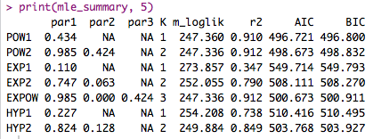

# Summary table with $∆AIC, ∆BIC$ values

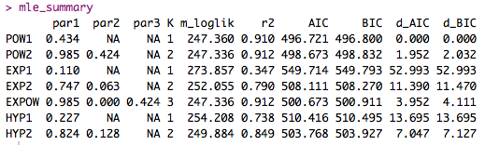

In the previous analysis of the models from Homework1, the EXPOW and POW2 models seemed to fit the data best, with the POW1 model as a close runner-up. However, the POW1 model has the lowest AIC value, with the POW2 and EXPOW models coming close. This is because POW1 is a single parameter models while POW2 and EXPOW have two and three parameters, respectively. In other words, the criterion values rewarded POW1 for its simplicity. But because the maximum number of parameters from any model is no more than three, there is not any huge deviation from the r2 analysis. Overall, it could reasonably be deduced that POW1 model is the best model considering its effectiveness and simplicity.

2. 1) ra\_prospect for a single subject

/Users/JaeWonKim/Dropbox/5-1/실험심리세미나/HW2/figures/ra_prospect_single.png

2. 2) ra\_prospect for all subjects

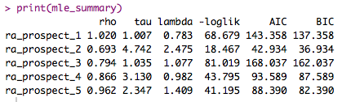

2. 3)

# ra\_prospect and ra\_noLA (fewer iterations, with local minima problem)

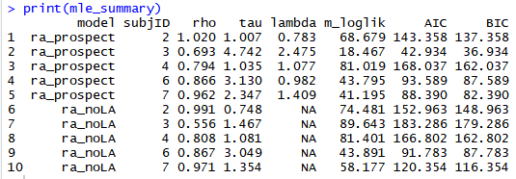

# ra\_prospect and ra\_noLA (local minima problem fixed)

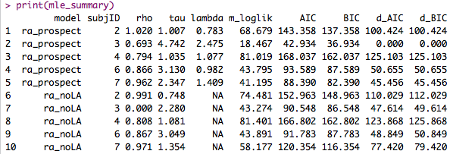

2. 4)

# Summary of AIC and BIC values for each model

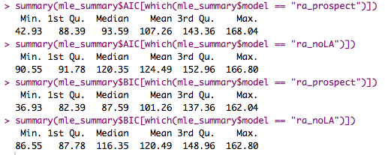

The risk aversion model with delta (a.k.a. ra\_prospect) seems to be the better model based on AIC and BIC values. Both the mean and median values of AIC and BIC are lower for the ra\_prospect model. The maximum value of the AIC is slightly larger on the ra\_prospect model, but the difference is negligible.